High-Level Design (HLD)
# Source: AI Source: Provided by: [Data Path: Persons Table -> ID Column: 1, Name_En Column: Motasem Essam] -> From: [ChatGPT] on [1/23/2026]
High-Level Design (HLD) is the part of software design that focuses on the big picture of the system. It defines how the system is structured and how components interact, without going into implementation details.
👉 HLD is like the architectural blueprint of a building.

🔑 Key Points of HLD
# Source: AI Source: Provided by: [Data Path: Persons Table -> ID Column: 1, Name_En Column: Motasem Essam] -> From: [ChatGPT] on [1/23/2026]
- Defines system architecture and components
- Shows how modules interact
- Identifies external interfaces (APIs, databases, services)
- Focuses on data flow and communication
- Used for planning before coding starts

🧱 What HLD Includes
# Source: AI Source: Provided by: [Data Path: Persons Table -> ID Column: 1, Name_En Column: Motasem Essam] -> From: [ChatGPT] on [1/23/2026]
- Architecture Diagrams
  - Layered architecture, client-server, microservices, etc.
- Module Design
  - Identify major modules/classes and their responsibilities
- Data Flow
  - How data moves between modules
- Interfaces
  - APIs, protocols, or communication mechanisms
- Technology Stack
  - Programming languages, frameworks, databases

❌ Bad Example (No High-Level Design)
Jumping directly to code:
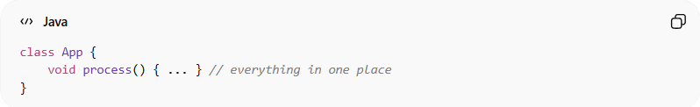
class App {
void process() { ... } // everything in one place
}
👉 Problems:
- No architecture
- No clear module separation
- Hard to scale and maintain

✅ Good Example (HLD Approach)
# Source: AI Source: Provided by: [Data Path: Persons Table -> ID Column: 1, Name_En Column: Motasem Essam] -> From: [ChatGPT] on [1/23/2026]
1. Architecture Diagram
Client → UserController → UserService → UserRepository → Database
2. Module Responsibilities
- UserController → Handles requests
- UserService → Business logic
- UserRepository → Database operations
3. Interfaces
- Controller communicates with Service via method calls
- Service communicates with Repository via data models

💡 Benefits of HLD
# Source: AI Source: Provided by: [Data Path: Persons Table -> ID Column: 1, Name_En Column: Motasem Essam] -> From: [ChatGPT] on [1/23/2026]
- Clear understanding of system structure
- Helps team members understand responsibilities
- Reduces risk of design errors
- Easier to scale or modify in the future

🧭 Key Idea
# Source: AI Source: Provided by: [Data Path: Persons Table -> ID Column: 1, Name_En Column: Motasem Essam] -> From: [ChatGPT] on [1/23/2026]
High-Level Design answers “What are the main parts of the system and how do they work together?”
It doesn’t go into code-level details (that’s Low-Level Design, LLD).

